Jack Aldworth

10/22/2024

Evolutionary Robotics

Project 5: Simulating a Body

Part 1: Design the Body

For my first body I decided to keep it simple and just make it 3 cubes that could roll up and expand. To do this I started by making three cubes all with a width, length, and height of 1. The first cube was at position [0,0,0.5] with a joint at [0.5,0,1]; the second cube was at [0.5,0,0.5] relative to the joint and had it’s own joint at [0,0,1]; and the third cube was at position [0.5,0,0.5] relative to the second joint. Both joints only rotate in the x direction. Below is the Design I made and the body In the simulation itself. The code used to generate the simulated body can be found here:

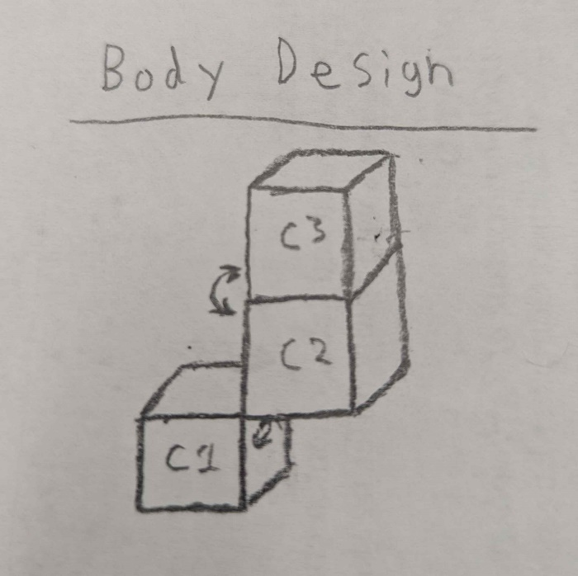

Figure : Body Design Figure : Body in Simulation

Here is a video of the moving around the simulated body: <https://drive.google.com/file/d/1btW84K-FFi6iMZACVDKfR1DX-4fpiR4h/view?usp=sharing>

Part 2: Create a Driving Signal to move the Body Forward

To cause this body to move forward I used an identical sine-based signal for both joints (fig. 3). This signal will cause cube 3 to “curl up” inside of cube 2 about half the time and have cube 1 move back and forth at the same time. This should cause the body to essentially “stand up” and “fall over” to move forward.

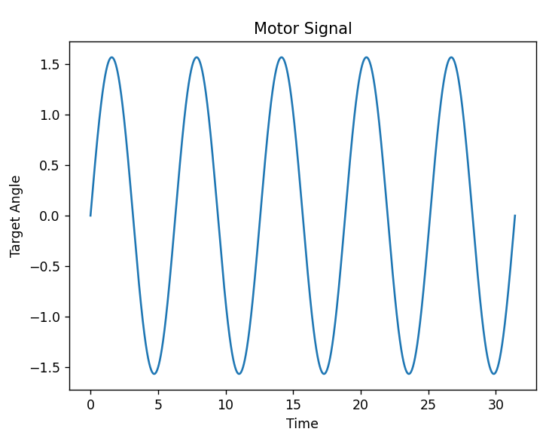

Figure : Plot of Control Signal

Here is a video of the body moving: <https://drive.google.com/file/d/1gk8Jz188zANZx-Mpvw2TZNHM3f0jZ9ID/view?usp=sharing>

Part 3: Create a second Body and compare

For my second body I wanted to try and make a body that moves through jumping. To do this I created a new body with two small feet and one large torso with most of its weight way in front of the feet (fig. 4), so that when the when the feet moved extremely quickly the body would be launched in the direction the torso was facing.

Figure : Second Body

For the movement I have both feet use the same signal again, but this time the Right foot inversed the signal so that both feet would rotate together. The motor signal this time would slowly rotate the feet back, before quickly trying to bring the feet back to the starting position (fig. 5). This would launch the whole body forward and up essentially “jumping.”

Figure : Body Two Motor Signal

You can find a video of the second body moving here: <https://drive.google.com/file/d/1-Uif4x2aETUDsgjY625qC1SEUnF9f8_3/view?usp=sharing>

Part 4: Potential of Future Work

I could see myself connecting pybullet to a neural network to make my final project. I would likely attempt to create some sort of human like walker that would have to balance itself and walk forward for as long as it can. I could also see myself attempting to make some sort of swimming body. However, due to the complexity of building models in pybullet, I do not see myself making a neural network that can create new bodies for itself.